The Spider and the Fly

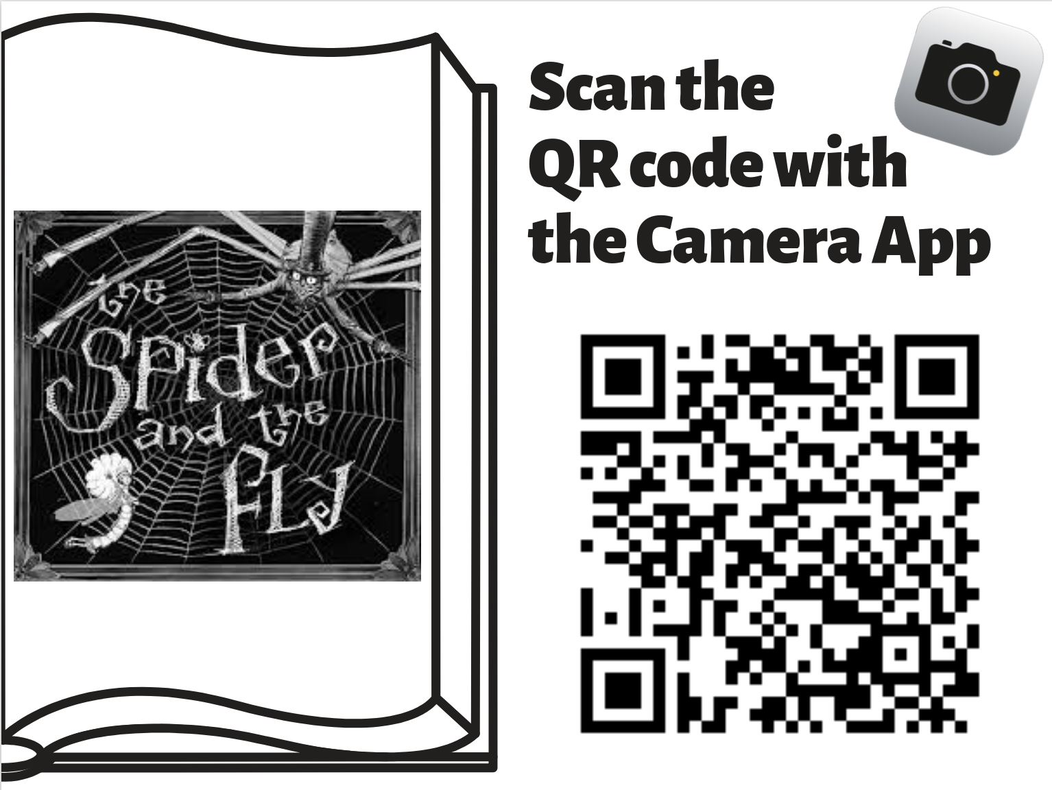

Prompt:
Using the information from The Spider and the Fly, create a thinking map that identifies the characters, setting, problem, and the solution. What was the problem in The Spider and the Fly? How was the problem solved?

ELA Standards:
2.W.TTP.3 Write narratives recounting an event or short sequence of events. a) Include details to describe actions, thoughts, and feelings. b) Use time order words to signal event order. c) Provide a sense of closure.
2.W.PDW.5 With guidance and support from adults, focus on a topic, respond to questions and suggestions from peers, and strengthen writing as needed by revising and editing.
2.W.RBPK.8 Recall information from experiences or gather information from provided sources to answer a question.
2.W.RW.10 With guidance and support from adults, engage routinely in writing activities to promote writing fluency.

Be sure to include:

Language:
- A variety of sentence structures
- Accuracy in grammar, spelling, punctuation and capitalization

Details:
- An opening sentence that restates the prompt.
- At least three sentences with details answering the prompt using evidence from the text
- A closing sentence
- Choice of words include some of the vocabulary words from the unit

Name: _________________________ Date: ___________________

Title of Story: __________________________________________________

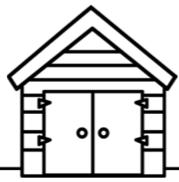
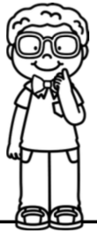
Story Elements Organizer
Solution
Problem
Setting
Characters

Name: _________________________ Date: ___________________

Title of Story: __________________________________________________

Story Elements Organizer
Solution
Problem
Setting
Characters

Spider

Fly
Outside and inside the Spider’s house at night time

The Spider wants the Fly to come into his parlor (web) so he can eat her.
The Spider flatters the Fly and tricks her into getting close enough so he could catch her.

What was the problem in The Spider and the Fly? How was the problem solved?

Topic Sentence

In the Spider and the Fly the problem was

Sentence 1: Proof from the story to explain the problem.
Sentence 2: Sentence to answer 2nd question.
What was the problem in The Spider and the Fly? How was the problem solved?

In the Spider and the Fly the problem was
Topic Sentence

Sentence 4: Restate the problem and solution.
Sentence 3: Proof from the story to explain how the problem was solved.

The problem was solved by the Spider telling the Fly many nice things about herself until she got close enough so he could catch her.
The Spider wove a web and set his table so he would be ready to eat the Fly.
What was the problem in The Spider and the Fly? How was the problem solved?

Topic Sentence
In the Spider and the Fly the problem was the Spider wanted to eat the Fly but she wouldn’t come to his house.

The Spider told the Fly how beautiful she was because he wanted her to get close enough so he could have her for dinner.
He told the Fly how beautiful her wings, clothes, head, and eyes were and tempted her with a mirror.

Model Paragraph

In the Spider and the Fly the problem was the Spider wanted to eat the Fly, but she wouldn’t come to his house. The Spider wove a web and set his table so he would be ready to eat the Fly. The problem was solved by the Spider telling the Fly many nice things about herself until she got close enough so he could catch her. He told the Fly how beautiful her wings, clothes, head, and eyes were and tempted her with a mirror. The Spider told the Fly how beautiful she was because he wanted her to get close enough so he could have her for dinner.

